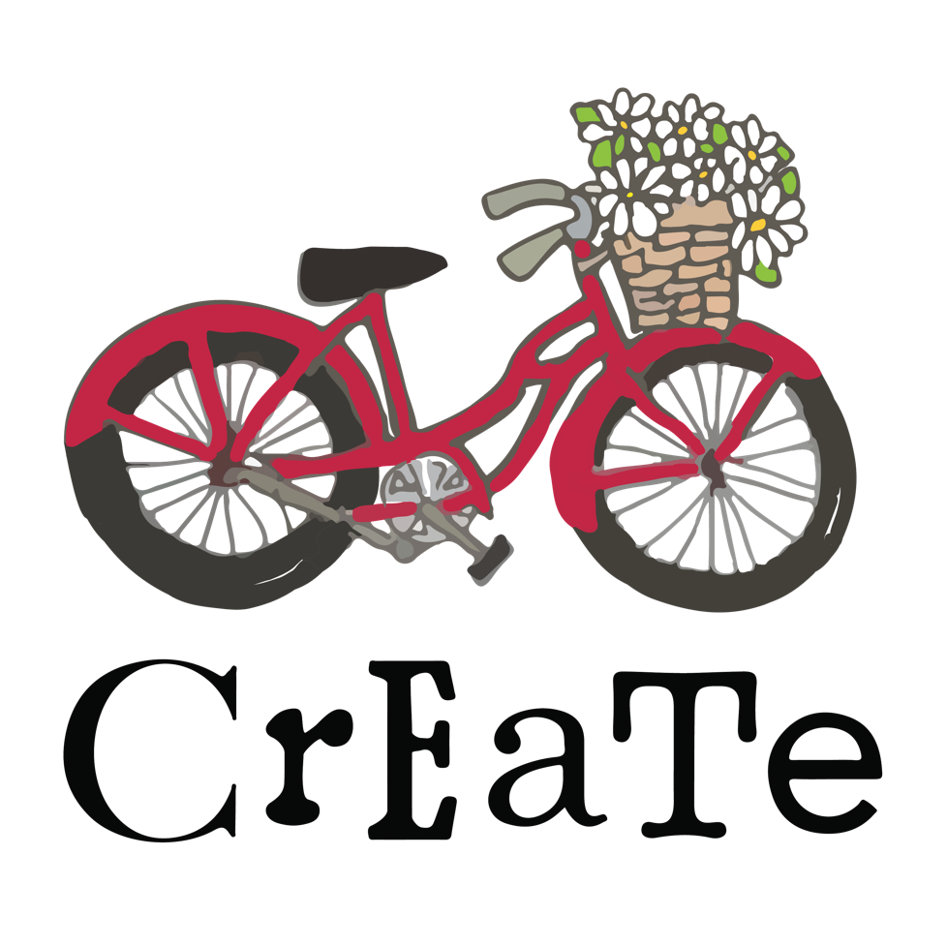
Pottery Studio

Studio Handbook
(Revised 1/2025)

Welcome to Create Pottery Studio!
We are a teaching studio, and our goal is to provide an engaging, collaborative, inclusive, fun-filled and respectful creative space and community of makers – Join Us!!

The care and keeping of our studio depends on each person understanding and carrying out the following policies and procedures:

General Policies and Procedures:
Supplies:
- Community tools are provided for each pottery class in the studio.
- Advanced pottery tools are in the open studios.
- Feel free to use your personal tools, mark each one with your name and store on your shelf.
- Clay is provided for pottery classes.
- Open studio makers and members will purchase clay from the studio. Only clay purchased from the studio will be fired in our kilns, unless permission is given by staff.
- Studio aprons are available to use for a class session. Keep your apron on your shelf and launder at home as needed. Place aprons in a laundry bag at the end of a class session.
Student Shelves:
- Each student is assigned a shelf in the studio for personal items, personal clay tools and work in process.
- Bisque and glaze fired pottery will be returned to your shelf by staff.
- Consolidate work as needed so that all your pottery fits on your shelf.
Studio Processes:
Bisque Firing
Once you have created your work it’s time to bisque fire it!
- Your piece should be completely trimmed, smoothed, etc. before its placed on the “READY TO BE BISQUED” shelf.
- Load the racks from back to front. This keeps others from having to move your pottery to make room for their own and reduces the chance of damage.
- Make sure your maker’s mark is on your work! (and on your shelf)
- All pieces are bisque fired to Cone 05.
- The frequency of bisque firing varies according to the amount of work being made.
- Pottery that is too thick will not be fired and will be returned to your shelf.
Glazing and Glaze Firing:
- Student pieces are typically glazed during the last class in a session.
- ALL WORK must be waxed on the bottom and 1/2” up the bottom edge, it is helpful to use the glaze stir sticks and small triangular pencils to mark your pots.
- Bucket glazes should be stirred up before each use.
- Each glaze bucket should have it’s own stir stick and glazing tongs.
- Do not contaminate glaze buckets by sharing sticks or tongs.
- Jar glazes should be shaken up. (Wipe off lids of glaze jars before recapping to make it easier to open the next time).
- If dipping, follow the submerge time on the lid of each glaze color. If double dipping, follow submerge time for the first dip and just do a quick in/out dip for the second.
- If brushing, apply 3 even coats to each piece.
- Inspect the bottom of each piece after glazing to be sure it is clean/free of any dried glaze.
- Place your pottery on the correct rack, e.g., labeled with your class name or on the open studio rack.
- Load the racks from back to front. This keeps others from having to move your pottery to make room for their own and reduces the chance of damage.
- You are required to clean up after yourself and leave your area cleaner than you found it.

Create Kiln Firing Policy:
- Only the studio work of registered students, open studio artists and instructors will be glazed and fired at Create.
- Create is not a commercial or production studio and is for educational and recreational use only.
- Exceptions to this policy can only be made by the Studio Owner/Manager.
- Only staff is allowed in the kiln area
- Only staff is allowed to load/unload the kilns
- Only staff is allowed to load/unload the black utility cart
- Please don’t touch/move other’s work. If you accidentally damage another maker’s work, please leave a note of apology so the maker doesn’t wonder what happened.
- Clay is an extremely fragile medium and as a result, the studio cannot guarantee that every piece made will make it through to the finished end. The studio staff will handle each piece with the utmost care, however, accidents do happen at any point in the process of loading/unloading kilns and the firing process as well.

Clean Up:
Clay is a messy process and leaves its mark on us, the wheel, the floor, the wall, and basically any porous surface. When you are finished, be sure you have not only wiped down all surfaces you worked on, but also cleaned and put away any tools you have used.

The last 20-15 minutes of all studio classes are dedicated to cleaning the work areas.

Here is our step by step Clean Up Process for Wheel:
1. Make sure there are no sponges, tools, etc. in your H2O bucket.
2. Turn off your wheel and move your work to shelves, cover with plastic
3. Return to wheel and make sure there are no sponges, tools, etc. in your H2O bucket.
4. Put all clay scraps/sludge in H2O bucket
5. Dump H2O bucket in blue buckets in the back, use sponge to get all clay out
6. Fill H2O bucket 1⁄2 way with water (Do Not Wash yet)-
7.No clay in sinks!!
8. Return to wheel and wipe off all tools, splash pan and wheel with this somewhat clean water
9. Dump all this H2O in blue buckets again
10. Clean H2O bucket at the sink and leave on drying shelf.
11. Now take tools to sink to rinse clean. Dry with towels and return to the pegboard (in correct spot)
12. Dampen big sponges to the le8ft of the sinks and wipe down wheels, splash pans, stool, floor around the wheels (use mop if needed)
13. Place pedal on wheel, move stool to the side-Do not turn stool upside down on the wheel
For Hand building:
Clean all tools, rollers, forms every time you use them so that they are ready for the next person. This is especially important because hand builders use brown and/or white clay and the possibility for contamination is increased if tools are covered in dust or residual clay.
Do not submerge any forms in water- GR Pottery forms, plaster, plastic or wooden forms- wipe all forms down with a damp sponge/rag.
Also never submerge rollers in water- wipe all rollers and all other tools with a sponge/rag, use a needle tool if intricate clay removal is needed and place back in their proper location.
Wipe slab mats with sponges and dry with a towel before putting back in their spot. Do not leave them out to dry and do not leave on the worktables when they are wet.
Wipe down your worktable thoroughly with a damp sponge.
Mop the floor around your work area as needed.
Never sweep in the studio, a shop vac is located in the utility closet if needed to clean the floor.

At CrEaTe we leave our studio areas better than we found it!

Safety Information:
First Aid Kit
A First Aid Kit is located in the back of the studio on the wall beside the “cloffice”
A choking aid and CPR vest are in the same area.

Fire Extinguisher
Fire Extinguishers are located beside front door and in the kiln areas.

Doors:
- The back door is to remain locked at all times.
- The front door will remain open during class times with a sign posted that says the studio is closed because class is in session.
- The front door can be locked during open studio time at the discretion of the folks present.
- The front door will always be locked if only one or two folks are present, or folks are only working in the open studio spaces and not in the front of the studio.
- Safety is our top priority and there is no need to open the doors to people that are not associated with our studio. We invite the public in numerous times during the year for studio events and all studio information can be found by others on our website.

Create Pottery Studio Community Policies
- Respectful interactions with others using the studio is both expected and required of ALL studio participants.
- Some makers like to work quietly, headphones are useful.
- Phone conversations should take place in the back of the studio, or outside, to not disrupt other makers.
- Kind, supportive words are always a good idea! Do not offer unsolicited opinions.
- We do not discuss politics, religion or other divisive topics in the studio- it is a safe place for everyone to work. Opinions are good, but please share them outside of studio time.
- Create prohibits harassment on any unlawful basis, including, but not limited to race, age, religion, disability, sexual orientation, etc. It considers harassment to be a major offense that can result in the termination of studio access.
- Create will not tolerate use of illegal drugs, or possession of firearms or concealed weapons on the property. Anyone found violating this policy will be asked to immediately leave the program.
- Alcohol is not permitted during working hours unless approved for a social function or private event.
- Create reserves the right to terminate studio privileges for what it deems the benefit of the community.

I am so happy you have joined us at Create!!
Please contact me with comments, suggestions or concerns:
Gin Scott, Owner
Create Pottery Studio
gin@createstatesville.com
704-437-4971
Studio Agreement and Waiver

____I have read and understand the policies and procedures of Create Pottery Studio LLC
____I agree to follow the policies and procedure of Create Pottery Studio LLC during my time in the studio.

In connection with my involvement in ceramic classes and/or open studio time at Create Pottery Studio LLC,
____I understand that working with clay and pottery equipment carries specific inherent risks to my health or/or personal injury.

____ I hereby release Create Pottery Studio LLC, its agents, representatives, assignees, including ownership, management and employees from all liabilities, actions, claims, damages, demands, costs and expenses which I am now or in the future have against them, arising out of or in any way connected with my participation in the pottery classes, open studio time, special events, including travel to and from sponsored events, such as day trips to Seagrove, NC.

____I understand that the waiver includes but is not limited to all injuries to me and or loss of injuries to any personal property.
____I also understand that this waiver includes but is not limited to any claims that are based on my alleged negligence or any other action or inaction of any of the above parties.

This Agreement and Waiver remains in effect throughout my association with Create Pottery Studio LLC.

Printed Name: ___________________________________________
Signed Name: ___________________________________________
Date: _______________________

